Acknowledgement

Completing a task is never one-man effort. It is often the result of invaluable contribution of number of individuals in a direct or indirect manner that helps in sharing a making success.

I take this opportunity to express my deep sense of gratitude and whole hearted thanks to my guide Abhaya Nand for their valuable guidance and keep interest and affection encouragement thought the work..

We take this opportunity to all those who have directly or indirectly helped me during the course of this task..

INDEX

CHAPTER NAME

CHAPTER 1 :Introduction / Objectives
  - Introduction

CHAPTER 2: System Analysis
  - System Analysis
  - Identification of Need
  - Preliminary Investigation
  - Feasibility Study
    - Technical Feasibility
    - Operational Feasibility
    - Economic Feasibility
      - Cost Estimation of The Project
    - Social Feasibility

CHAPTER 3: Software Engineering Paradigm
  - Waterfall Model

CHAPTER 4: Software Requirements Specification
  - Software Requirements Specification
    - Functional Requirements
    - Purpose of the Document
    - Scope of the Development Project
    - Overview of the Document
    - General Description
    - Hardware Interface Requirement
    - Performance Requirement

CHAPTER 5: Design
  - Design Objectives
  - Introduction
  - Software Design
  - Design Quality Criteria
  - Design Concepts
    - Top down and Bottom up Strategies
  - Abstraction
  - Refinement
  - Modularity
  - Detailed Design

    - Data Design
      - Data Structures
      - Triggers
    - Architectural Design
      - Context Flow Diagram
      - Summary of the Modules
      - Data Flow Diagrams
    - Interface Design
      - Input / Output Forms

CHAPTER 6: Coding

CHAPTER 7: Code Efficiency

CHAPTER 8: Optimization of Code

CHAPTER 9: Validation Checks

CHAPTER 10: Testing
  - Testing Objectives
  - Testing Principles
  - Testing Fundamentals
  - Test Cases & Test Criteria
  - Black Box Testing
  - White Box Testing
  - Boundary Value Analysis
  - Functional Testing
  - Structural Testing
  - Levels of Testing
    - Unit Testing
    - Integration Testing
    - Regression Testing
    - Validation Testing
    - System & Acceptance Testing

CHAPTER 11: Implementation

CHAPTER 12: Maintenance

CHAPTER 13: Reports

CHAPTER 14: Bibliography

1. Introduction

It is a sample project, which shows the functioning of Member Ship of any Club. In this project we use VB as front end and Access as back end.

The main objectives for developing this project are…

- Managing all main functioning of Member Ship.

- Managing records of customer as well their type of customer information.

- Managing Bill information.

- Managing user feedback/Suggestion information.

2. System Analysis

2.1 System analysis
System analysis is conducted with the following objectives in mind:

- Identify the customers need.

- Evaluate the system concept for feasibility.

- Perform economic and technical analysis.

- Allocate functions to hardware, software, people, database and other system elements.

- Establish cost and schedule constraints.

- Create a system definition that forms the foundation for all subsequent engineering .

  - IDENTIFICATION OF NEED

The analyst meets the customer and the end user(if different from the customer).

The customer may be a representative of the company for which the software is

being developed, or the marketing department of the developing company etc. Here

the intent is to understand the product objectives and to define the goals to fulfill

the requirements.

2.3 PRELIMINARY INVESTIGATION

The purpose of the preliminary investigation is to evaluate project requests. It is not

a design study nor does it include the collection of details to describe the business

system in all respects.

Analysts working on the preliminary investigations should accomplish the

following objectives :

- Clarify and understand the project request.

- Determine the size of the project.

- Assess costs and benefits of alternative approaches.

- Determine the technical and operational feasibility of alternative approaches.

- Report the findings to management, with recommendations outlining the
acceptance or rejection of the proposal.

2.4 FEASIBILITY STUDY

The concept of feasibility is to determine whether or not a project is worth

doing. The process followed in making this determination is called

feasibility study. Once it has been determined that a project is feasible, the

system analyst can go ahead and prepare the project specification which

finalizes project requirements.

Types of feasibility

- Technical Feasibility

- Operational Feasibility

- Economic Feasibility

- Social Feasibility

- Management Feasibility

- Legal Feasibility

- Time Feasibility

Here we describe only few of these in detail: -

2.4.1 TECHNICAL FEASIBILITY

This is concerned with specifying equipment and software that will

successfully satisfy the user requirement. Technical needs of the system

include: -

- Facility to produce outputs in a given time

- Response time under certain conditions

- Ability to process a certain volume of transaction at a particular period

- Facility to communicate data to distant location

In examining technical feasibility, configuration of the system is given more

importance than the actual make of hardware. Configuration should give

the complete picture about the system’s requirements: how many

workstations are required, how these units are interconnected so that they

could operate and communicate smoothly. What speeds of input and output

should be achieved at particular quality of printing.

The computers are easily available in almost all the places, even in villages.

The hardware needed to carry out this project include workstations with 64

MB of RAM and 2 GB HDD.

The software needed to carry out this project include Visual Basic 6.0 as

front end and Oracle 8 as backend. So the technology required to carry out

the project is easily available and affordable, hence this project is

technically feasible.

Due to all these reasons implementation of such system becomes not only

feasible but reputed to the organization.

    - OPERATIONAL FEASIBILITY

This is mainly related to human organization and political aspects. The

points to be considered are: -

- What changes will be brought with the system?

- What organizational structures are disturbed?

- What new skills will be required? Do the existing staff members have these skills? If not, can they be trained in due course of time

This feasibility study is carried out by a small group of people who are familiar

with information system techniques, who understand the parts of business that are

relevant to the project and are skilled in system analysis and design process.

This projects are not developed just for fun. They are developed on demand of the

organization for which the system is being developed. Therefore the chances of

resistance from the college staff are almost nil. Any disturbance to the organization

if occurs will be advantageous to the organization. Also the time required to carry

out a transaction will be reduced to a large extent, which will make the student

happy and cheerful. The operators now will be able to service more students than

before in the same time period. There is no need to recruit new staff to operate the

system. The existing staff of the college can be trained to interact with the system

which is a GUI based software and is easy to use. Hence the project is

operationally feasible.

    - ECONOMIC FEASIBILITY

Economic analysis is the most frequently used technique for evaluating the
effectiveness of a proposed system. More commonly known as cost-benefit analysis; the procedure is to determine the benefits and savings that are expected from a

proposed system and compare them with costs. If benefits outweigh costs, a

decision is taken to design and implement the system.

Cost-benefit analysis

Since cost plays an important role in deciding the new system, it must be identified

and estimated properly. Benefits are also of different types and can be grouped on

the basis of advantages they provide to the management.

Cost-saving benefit leads to reduction in administrative and operational costs.

Cost-avoidance benefits eliminate future administrative and operational costs

Improved-service-level benefits are those where the performance of the system is

improved by a new computer based method e.g. servicing a customer in two

minutes rather than five to ten minutes is an example of this type of benefit.

Improved-information benefits is where computer based methods lead to better

information for decision making

Direct Or Indirect Costs And Benefits

Direct costs are those which are directly associated with a system. They are applied

directly to the operator.

Direct benefits also can be specifically attributable to a given project.

Indirect costs are not directly associated with a specific activity in the system. They

are often referred to as overhead expenses.
For example cost of space to install a system, maintenance of computer center,

heat, light and air-conditioning are all tangible costs but their proportion is

difficult to calculate to a specific activity like report.

Indirect benefits are realized as by-products of another system.

We can define cost-benefit analysis as: -

- That method by which we can find and estimate the value of the gross benefits of a new system specification.

- That method by which we find and determine the increased operating costs associated with the gross benefits

- The subtraction of these operating costs from the associated gross benefits to arrive at net benefits.

- That method by which we find and estimate the monetary value of the development costs that produce the benefits

- Those methods by which we show the time-relationship between net benefits and

development costs as they relate to cash flow, payback on investment, and time-in

process taking into operation factors such as inflation etc.

COST ESTIMATION OF THE PROJECT

The primary reason for cost and schedule estimation is to enable the client

or developer to perform a cost-benefit analysis and for project monitoring

and control. Cost and schedule estimates are also required to determine the

staffing level for a project during different phases.

Cost in a project is due to the requirements for software, hardware, and

human resources. Hardware resources are such things as the computer

time, terminal time and memory required for the project, whereas software

resources include the tools and the compilers needed during development.

The bulk of the cost of software development is due to the human resources

needed, and most cost estimation procedures focus on this aspect. Most of

the estimates are determined in terms of person-months (PM)

The primary factor that controls cost is the size of the project, i.e., the larger

is the project, the higher the cost and resource requirement. Other factors

that affect the cost include programmer ability, experience of the developer

in the area of interest, complexity of the project, and reliability

requirements.

The most common approach for estimating effort is to make it a function of

a single variable i.e. , the project size. The equation of effort is

EFFORT = a * SIZE ^{b}

where a and b are constants. Also,

EFFORT = a * SIZE + b

Most models have used LOC (lines of code) as the size measure.

The COCOMO (Constructive Cost Model) Model estimates the total effort

in terms of PM of the technical project staff. The basic steps in this model

are: -

- Obtain an initial estimate of the development effort from the Estimate of thousands of delivered lines of source code.

- Determine a set of 15 multiplying factors from different attributes of the project.

- Adjust the effort estimate by multiplying the initial estimate with all the multiplying factors.

The initial estimate is determined by an equation of the form used in the

static single-variable models, using KDLOC as size measure.

EFFORT = a * (KDLOC) ^{b}

The values of a and b depend on the project type.

There are 15 different attributes, called cost driver attributes, that determine the

multiplying factors: -

COST DRIVERS | RATING
COST DRIVERS | Very low | Low | Normal | High | Very high
PRODUCT ATTRIBUTES | 0.75 | 0.88 | 1.00 | 1.15 | 1.40
RELY, required reliability |  | 0.94 | 1.00 | 1.08 | 1.16
DATA, database size | 0.70 | 0.85 | 1.00 | 1.15 | 1.30
CPLX, product complexity
COMPUTER ATTRIBUTES |  |  | 1.00 | 1.11 | 1.30
TIME, execution time constraint |  |  | 1.00 | 1.06 | 1.21
STOR, main storage constraint |  | 0.87 | 1.00 | 1.15 | 1.30
VITR, virtual machine volatility |  | 0.87 | 1.00 | 1.07 | 1.15
TURN, computer turnaround time
PERSONNEL ATTRIBUTES | 1.46 | 1.19 | 1.00 | 0.86 | 0.71
ACAP, analyst capability | 1.29 | 1.13 | 1.00 | 0.91 | 0.82
AEXP, application experience | 1.42 | 1.17 | 1.00 | 0.86 | 0.70
PCAP, programmer capability | 1.21 | 1.10 | 1.00 | 0.90
VEXP, virtual machine experience | 1.14 | 1.07 | 1.00 | 0.95

PROJECT ATTRIBUTES
MODP, modern programming practices | 1.24 | 1.10 | 1.00 | 0.91 | 0.82
TOOL, use of S/W tools | 1.24 | 1.10 | 1.00 | 0.91 | 0.83
SCHED, development schedule | 1.23 | 1.08 | 1.00 | 1.04 | 1.10

The multiplying factors for all 15 cost drives are multiplied to get the effort

adjustment factor (EAF). The final effort estimate, E, is obtained by multiplying

the initial estimate with EAF: -

E = EAF * E_{i}

Member Ship Project generally require only one time investment which are

not much for such an industry. Hardware cost is becoming very low day by day, so

that computers are now easily affordable. For updation of the system we require

little money and resources. It makes such a project economically feasible.

    - SOCIAL FEASIBILITY

It is the determination of whether a proposed project will be acceptable to the

people or not. This determination typically examines the probability of the project

being accepted by the group directly affected the proposed system change.

To solve the actual problems in an industry setting, a software or a team of

engineers must incorporate a development strategy that encompasses the process,

methods, and tools layers. This strategy is often referred to as a process model or a

software engineering paradigm. A process model for software engineering is

chosen based on the nature of the project and application, the methods and tools to

be used and the controls and deliverables that are required.

The software engineering paradigm that we have chosen for the project is Waterfall model.

3. Software Engineering Paradigm

3.1 WATERFALL MODEL:

This model is also known as Linear Sequential Model or Classic Life Cycle Model.

It states that the phases are organized in a linear order. With this model, the

sequence of activities is performed in a software development project is :

- Requirement Analysis

- Project planning

- System design

- Detailed design

- Coding and unit testing

- System integration and testing

Linear ordering of activities has some important consequences. First to clearly

identify the end of a phase and the beginning of the next, some certification

mechanism has to be employed at the end of each phase. this is usually done by the

some verification and validation means that will ensure that the output of a phase is

consistent with the input of the phase, and that the output of the phase is consistent

with the overall requirements of the system. The consequence of the need for

certification is that each phase must have some defined output that can be

evaluated and certified. The outputs of the phases are often called work products

and are usually in the form of documents like requirements document or design

document. For the coding phase, the output is code.

There are two basic assumptions for justifying the linear ordering of the phases in

the manner proposed by the waterfall model :

- For a successful project resulting in a successful product, all phases listed in the waterfall model must be performed anyway.

- Any different ordering of the phases will result in a less successful product.

A successful software product is one that satisfies all the objectives of the

development project. These objectives include satisfying the requirements and

performing the development within the time and cost constraints.

LIMITATIONS OF THE WATERFALL MODEL:

The waterfall model although widely used, has received some criticism which are as follows:

The waterfall model assumes that the requirements of a system can be frozen before

the design begins. This is possible for the systems designed to automate an existing

manual system. For our project this limitation of the waterfall model has become a

virtue. But for new systems, determining the requirements is difficult as the users

does not even know the requirements. Hence having unchanging requirements is

unrealistic for such projects.

Freezing the requirements usually requires choosing the hardware. A large project

might take a few years to complete. If the hardware is selected early, then due to the

speed at which hardware technology is changing, it is likely that the final software

will use a hardware technology on the verge of becoming obsolete. This is clearly

not desirable for such expensive projects. Since our project is a medium scale

project, the chances of hardware becoming obsolete are very low.

The waterfall model stipulates that the requirements be completely specified before

the rest of the development can proceed. In some situations, it might be desirable to

first develop a part of the system completely and then later enhance the system in

phases.

It is a document driven process that requires formal documents at the end of each

phase. This approach tends to make the process of documentation heavy and is not

suitable for many applications particularly interactive applications where

developing elaborate documents of the user interfaces is not feasible.

System feasibility

validation

Requirement
Analysis &
Project
Planning validation

Feasibility Report

Requirements Document
And Project Plan
System Design

Verification

Detailed Design

Verification

System Design
Document
Detailed Design Document Programs Test Plan, Test Report &
Coding

Verification

Testing & Integration

Manuals Installation Report
Installation

Operations &
Maintenance

- Software Requirements Specification

4.1 SOFTWARE REQUIREMENT SPECIFICATION
I. Introduction
- Purpose of this Document
- Scope of the Development Project
- Definitions, Acronyms, and Abbreviations
- References
- Overview of the document

General description
- User Persons and Characteristics
- Product Perspective
- Overview of functional requirements
- Overview of Data Requirements
- General constraints, Assumptions, Dependencies and Guidelines
- User view of product use

Specific Requirements
- External interface requirements
- Detailed description of functional requirements
- Performance requirements
- Quality attributes
- Other requirements

Behavioral Description
- System states
- Events and actions

Validation and criteria
- Performance bounds
- Classes of tests
- Expected software response
- Special considerations

Bibliography
VII. Appendix

The introduction states the goals and objectives of software, describing it in the context

of computer based system. It may be nothing more than the software scope of the

planning document.

The information description provides a detailed description of the problem that the

software must solve. Information content and relationships, flow and structure are

documented. Hardware, software and human interfaces are described for external system

elements and internal software functions.

A description of each function is required to solve the problem, is presented in the

functional description.

The behavioral description section of the specification examines the operation of the

software as a consequence of external events and internally generated control

characteristics.

In validation criteria we specify, what classes of tests must be conducted to validate

function, performance and constraints? Constraints identify limits placed on the software

by external hardware, available memory or other existing systems

The bibliography contains references to all documents that relate to the software. These

include other software engineering documentation, technical references, vendor

literature, and standards.

The appendix contains information that supplements the specification. Tabular data,

detailed description of algorithms, charts and graphs are presented as appendices.

4.1.1 FUNCTIONAL REQUIREMENTS

Functional requirements specify which outputs should be produced from the given inputs.

They describe the relationship between the input and output of the system. For each

functional requirement, a detailed description of all the data inputs and their source, the

units of measure, and the range of valid inputs must be specified.

All the operations to be performed on the input data to obtain the output should be

specified. This includes specifying the validation checks on the input and output data .
4.1.2 PURPOSE OF THIS DOCUMENT

The purpose of this document is to convey the requirements of the project (as specified by

the client) to the programmers to ensure that the programmers understand and fulfill the

requirements to the expectation of the client.

Secondly, this document is used to ensure that the development team understands the

requirements specified by the client. This document will act as the contract for all future

development; all development spawns from and adheres to the details in the

requirements. The SRS also outlines the performance requirements that may be set and

required by the client/user.

References
Software Engineering Fundamentals by Ali Behforooz and Frederick J. Hudson
(Oxford University Press, 1996).

Software Engineering, A Programming Approach by Pressman(2nd Edition, Prentice Hall, 1992).

An integrated approach to Software Engineering by Pankaj Jalote (Narosa Publishing

House, 2nd edition). URL of home page is http://www.springer-ny.com/supplements/jalote

Fundamentals of Software Engineering by Carlo Ghezzi, Mehdi Jazayeri, Dino Mandrioli

(Prentice Hall India).

4.1.4 Overview of Document

The remainder of this document describes the intended users that would be expected to

interact with the system frequently, and a simple profile of each user type is provided as a

sample. This document now will go into more detail on the expected users their interface

and interaction with the product and more on the technical approach and considerations

to be implemented.

4.1.5 General Description

User Persons and Characteristics

The primary users of this product are the college employees, director perspective

candidates. Most of them already have some experience in using computer components

(mouse and keyboard), and are willing to learn and explore under the supervision of

their superiors. The employees have adequate knowledge so that they can be trained

easily to operate the system.

Overview of Functional Requirements

Our product will be stand alone and will have an interface, which can be accessed on

more than one-computer at the same time, such as computers connected with LAN. Our

main goal is to present facts on a comprehensive level, and make it easier as well.

4.1.6 Hardware Interface Requirements:

Our product will require at least a PowerPC Macintosh or a Pentium class PC with 64
MB of RAM (64+ recommended), and color display.
Other Software Components:
Operating System: WindowME/NT/2000
Detail Description of Functional Requirements

Template for describing functional requirements

Purpose | A description of the functional requirement and its motivations(s)
Inputs | which inputs; in what form/format will inputs arrive; from what sources input will be derived; legal domains of each input element
Processing | Describes the outcome rather than the implementation; include any validity checks on the data, exact timing of each operation (if needed), how to handle unexpected or abnormal situations
Outputs | the form, shape, destination, and volume of the output; output timing; range of parameters in the output; unit measure of the output; process by which the output is stored or destroyed; process for handling error messages produced as output.

Performance Requirements

The software is inherently designed to handle multiple users accessing the same database

system. Multiple user sessions will concurrently exist. Each session will receive it's own

thread of execution which is invisible to all other components of the system, but will

provide reliability, efficiency, and excellent response time. The actual capacity of users

that the system can handle is out of the scope of this document (this is a systems issue that

should be considered at a maintenance /administrator design level).

- Design

5.1 DESIGN OBJECTIVES

The primary objective of design is to deliver the requirements as specified in the

feasibility report. Following objectives should be kept in mind: -

- PRACTICALITY

The system must be stable and can be operated by people with average intelligence.

- Efficiency

This involves accuracy, timeliness and comprehensiveness of the system output.

- Cost

It is desirable to aim for a system with a minimum cost subject to the conidition that it

must satisfy all the requirements.

- Flexibility

The system should be modifiable depending on the changing needs of the user. Such

modifications should not entail extensive reconstruction or recreation of software. It

should also be portable to different computer systems.

- Security

This is very important aspect of the design and should cover areas of hardware

relaibility, fall back procedures, physical security of data and provision for detection of

fraud and abuse.

5.2 INTRODUCTION

The aim of system design, which is sometimes also refferred to as top-level design, is to

identify the modules that should be in the system, the specifications of these modules, and

how they interact with each other to produce the desired results. At the end of the system

design all the major data structures, file formats, output formats and the major modules

in the system and their specifications are needed.

5.3 Software design

Software design is an iterative process through which requirements are translated

into a “blueprint” for constructing the software. Characteristics that serve as a

guide for the evaluation of a good design: -

- The design must implement all of the explicit requirements contained in the

analysis model, and it accommodate all of the implicit requirements desired by

the customer.

- The design must be a readable, understandable guide for those who generate

code and for those who test and subsequently maintain the software.

- The design should provide a complete picture of the software, addressing the

data, functional, and behavioral domains from an implementation perspective.

5.4 DESIGN QUALITY CRITERIA

- A design should exhibit a hierarchical organization that makes intelligent use of control among the elements of software.

- A design should be modular i.e. the software should be logically
partitioned into elements that perform specific functions and sub
functions.

- A design should contain both data and procedural abstraction.

- A design should lead to modules that exhibit independent functional characteristics.

- A design should lead to interfaces that reduce the complexity of
connections between modules and with the external environment.

- A design should be derived using a repeatable method that is driven by information obtained during software requirement analysis.

All these things are implemented in our project using options on the main menu

screen. Each option provides a different kind of information, providing modular

approach. Data is submitted to the database as server side programming, which

gives abstraction to the data using middle tier concepts with fully Object-Oriented

programming.

5.5 Design concepts

A set of fundamental software design concepts has evolved: -

- What criteria can be used to partition software into individual components?

- How is function or data structure detail separated from a conceptual representation of the software?

- Are there uniform criteria that define the technical quality of a software design?

5.5.1 Top-down and bottom up strategies

A system consists of components, which have the components of their own, indeed

a system is a hierarchy of components. The highest level component corresponds

to the total system.

A top-down design approach starts with identifying the major components of the

system, decomposing them into their low-level components and iterating until the

desired level of detail is achieved. Top-down design methods often result in some

form of stepwise refinement. Starting from an abstract design, in each step the

design is refined to a more concrete level, until we reach a level where no more

refinement is needed and the design can be implemented directly.

A bottom-up design approach starts with designing the most basic or primitive

components and proceeds to higher-level components that use these lower-level

components. Bottom-up methods works with layers of abstraction. Starting from

the very bottom, operations that provide a layer of abstraction are implemented.

The operations of this layer are then used to implement more powerful operations

and a still higher layer of abstraction, until the stage is reached where the

operation supported by the layer are those desired by the system.

5.6 ABSTRACTION

“The psychological notion of “abstraction” permits one to concentrate on a problem at

some level of generalization without regard to irrelevant low level details; use of

abstraction also permits one to work with concepts and terms that are familiar in the

problem environment without having to transform them to an unfamiliar structure...”

  - Procedural abstraction
  - Data abstraction

- PROCEDURAL ABSTRACTION

It is a named sequence of instructions that has a specific and limited function.

- DATA ABSTRACTION

It is a named collection of data that describes a data object.

5.7 REFINEMENT

Stepwise refinement is a top-down strategy and the architecture of a program is

developed by successive refining levels of procedural details

“In each step of refinement, one or more instructions of the given program are

decomposed into more detailed instructions. This successive decomposition or

refinement of specifications terminates when all instructions are expressed in

terms of an underlying computer or programming languages… As tasks are

refined, so the data may have to be refined, decomposed, or structured, and it is

natural to refine the program and the data specifications in parallel.”

Every solution is always refinable depending on time period and availability of

information.

5.8 MODULARITY

“Modularity is the single attribute of software that allows a program to be

intellectually manageable”. Monolithic software can’t be easily grasped by a

reader. The number of control paths, span of reference, number of variables, and

overall complexity would make understanding close to impossible.

STRUCTURED DESIGN

Structured design methodology views every software system as having some inputs that

are converted into the desired outputs by the software system. The software is viewed as a

transformation function that transforms the given inputs into the desired outputs, and the

central problem of designing this transformation function. Due to this view of software,

the structured design methodology is primarily function oriented and relies heavily on

functional abstraction and functional decomposition. The appraoch begins with a system

specification that identifies inputs and outputs and describes the functional aspects of the

system. The next step is the definition of the modules and their relationship with one

another in a form called a structure chart, using data dictionary and other structured

tools.

Entity-relationship diagram

The E-R diagram enables a software engineer to fully specify the data objects that are

input and output to/from a system, the attributes that define the properties of these

objects, and the relationship between the objects. The following approach is taken: -

- During requirements gathering, customers are asked to list the “things”

that the application or business process addresses. These “things” evolve into a

list of input and output data, objects as well as external entities that produce or

consume information.

- Taking the objects one at a time, the analyst and customer define whether
or not a connection (unnamed at this stage) exists between the data, object.
and other objects.
- Wherever a connection exists, the analyst and customer create one or more object-relationship pairs.

- For each object-relationship pair, cardinality and modality are explored.

- Steps 2 through 4 are continued iteratively until all object-relationship
pairs have been defined. It is common to discover omissions as this process
continues. New objects and relationships will invariably be added as the
numbers of iterations grows.

- The attributes of each entity are defined. An entity-relationship diagram is formalized in review.

- Steps 1 through 7 are repeated until data modeling is complete.

DATA FLOW DIAGRAMS AND DATA DICTIONARY

DFD's are commonly used during problem analysis. Data flow diagrams are not limited

to poblem analysis for software requirement specification.

A DFD shows the flow of data through the system. It views a system as a function that

transforms the inputs into desired outputs. The DFD aim to capture the transformations

that take place within a system to the input data so that eventually the output data is

produced. The agent that performs the transformation of data from one state to another is

called a process (or bubble). The processes are shown by named circles and data flows

are represented by named arrows entering or leaving the bubbles. A rectangle represents

a sourcs or sink and is a net originator or consumer of data.

It should be pointed out that DFD is not a flowchart. A DFD represents the flow of data,

while a flowchart shows the flow of control. A DFD does not represent procedural

information. In drawing the DFD the designer has to specify the major transforms in the

path of the data flowing from input to output.

DATA DICTIONARY

Data dictionary is a repository of various data flows defined in data flow diagram. The

associated data dictionary states precsiely the structure of each data flow in DFD.

Although the format of dictionaries varies from tool to tool, most consists of the

following information:

- Name – the primary name of the data or control item, the data store or an external entity

- Alias – other names used for the first entry

- Where-used/how-used – a listing of the processes that used the data or control item

and how it is used (E.g. input to the process, output from the process, as a store, as an

external entity)

- Content description – a notation for representing content

- Supplementary information – other information about data types, preset values (if

known), restrictions of limitation

  - DETAILED DESIGN

During detailed design, the internal logic of each of these modules specified in system

design is decided. During this phase further details of data structures and algorithmic

design of each of the modules is specified. The logic of a module is specified in a high-

level design descriptional language, which is independent of the target language in which

software will eventually be implemented.

    - DATA DESIGN

The Data design transforms the information domain model created during analysis into

the data structures, that will be required to implement the software. The data objects and

the relationships defined in the entity relationship diagram and the detailed data content

depicted in the data dictionary provide the basis for the data design activity.

5.9.1.1 DATA STRUCTURES (TABLES ETC. ) OF ALL MODULES

-:Data Structures ( Tables ) Of Each Module :-

Table Name :- BILL

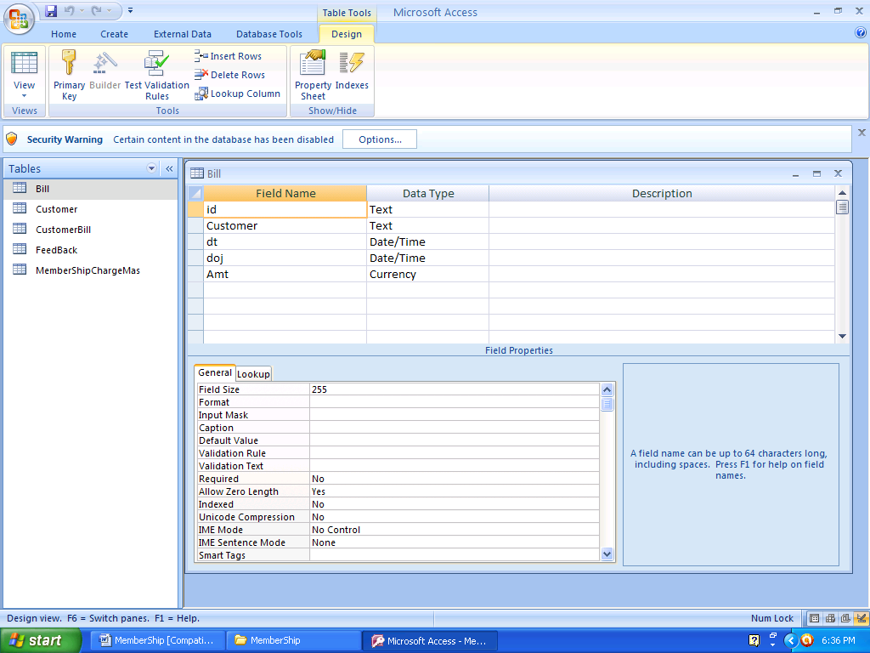

Table Name :- CUSTOMER

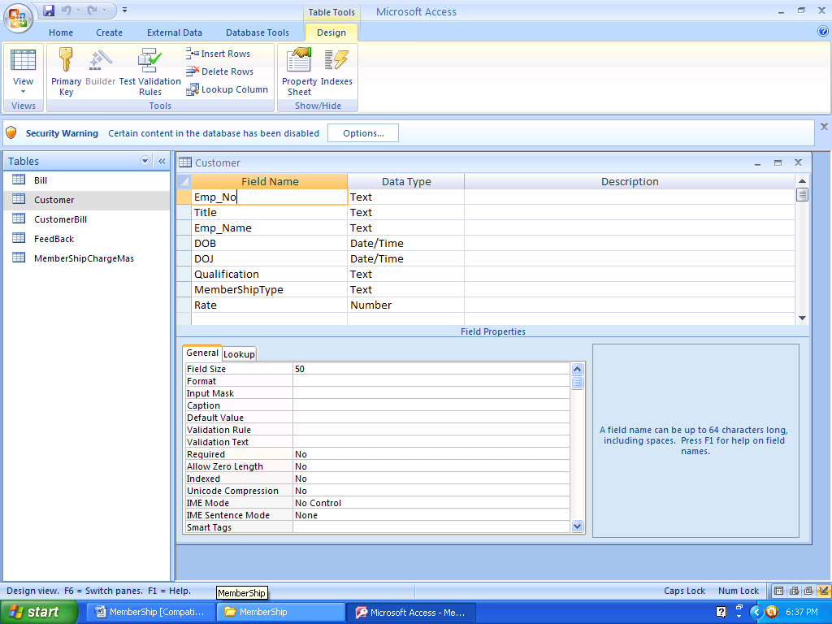

Table Name :- CUSTOMER BILL

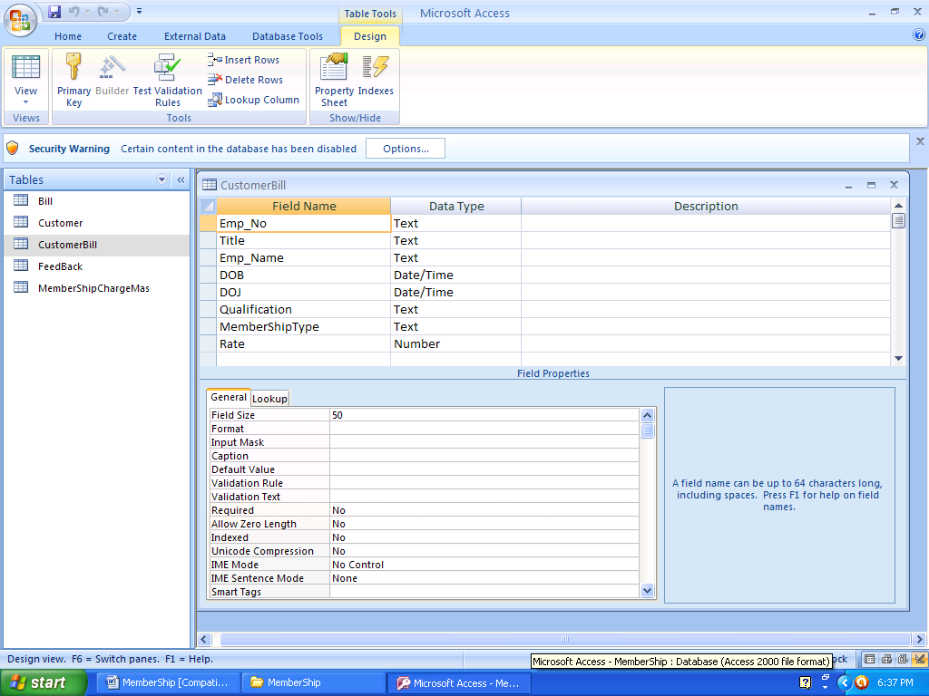

Table Name :- FEEDBACK

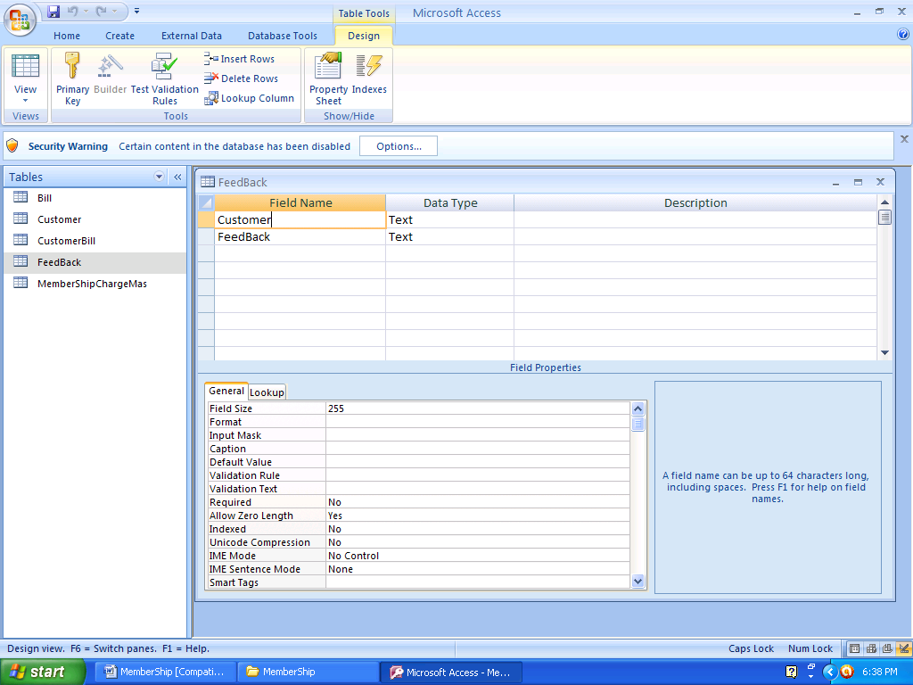

Table Name :- MEMBERSHIP CHARGES

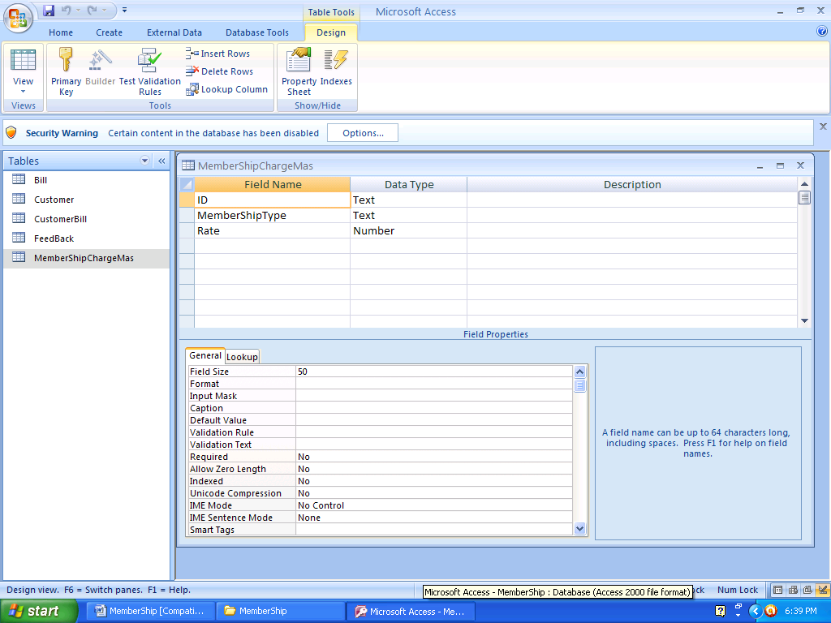

5.9.2 ARCHITECTURAL DESIGN

Architectural design represents the structure of data and program components that are

required to build a computer based system. It considers the architectural style that the

system will take, the structure and properties of the components that constitute the

system, and the interrelationships that occur among all architectural components of a

system. The architectural design defines the relationship between major structural

elements of the software, the “ design patterns” that can be used to achieve the

requirements that have been defined for the system, and the constraints that affect the

way in which architectural design patterns can be applied. The architectural design

representation-the framework of a computer based system-can be derived from the

system specificaion, the analysis model and the interaction of subsystems defined within.

ZERO LEVEL DFD

-

USER

DATA
OUTPUT

MEMBERSHIP
MANAGEMENT
SYSTEM

DATA AS INPUT
PROCESSED DATA

REPORT

6.2) ENTITY RELATIONSHIP(ER) DIAGRAMS

Feed Back
Customer Bill
Customer Type

ADDS
Name

Registration Id
Amount

CREATEEE

ADMINISTRATOR
PHONE NO.

NAME

ADDRESS
Customer

CLUB MEMBER
Using
AGE
TYPE

MEMBER NAME

CLUB MEMBER ID
REGISTERATION NO.

- FORMS

LOGIN PAGE

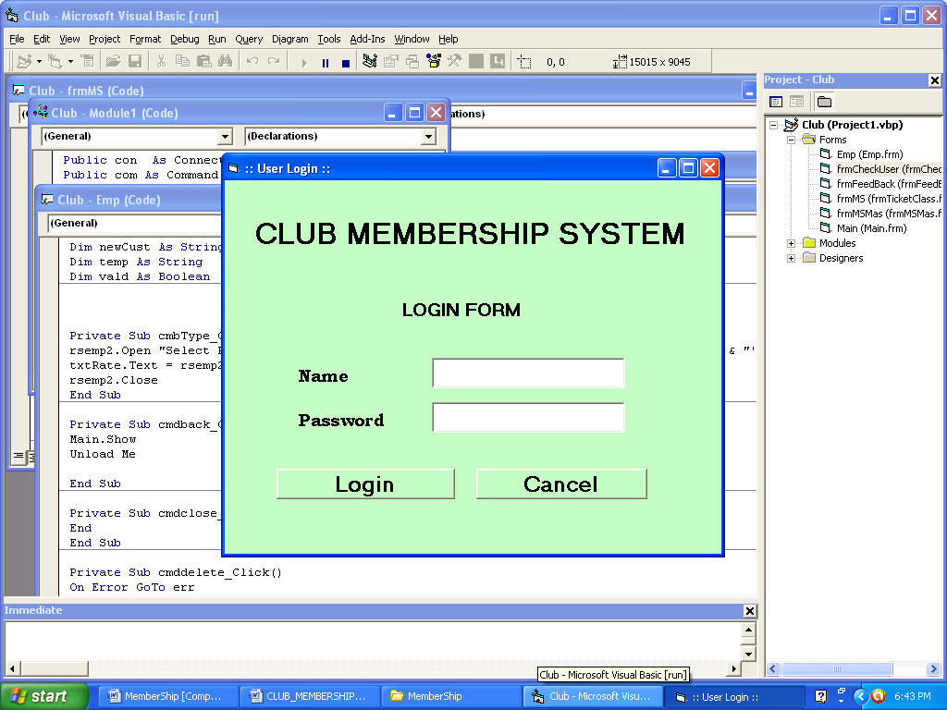

Home page

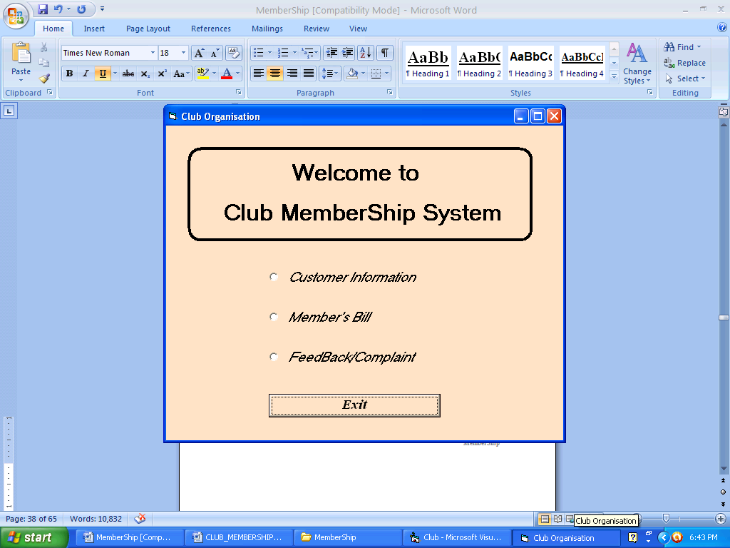

customer details

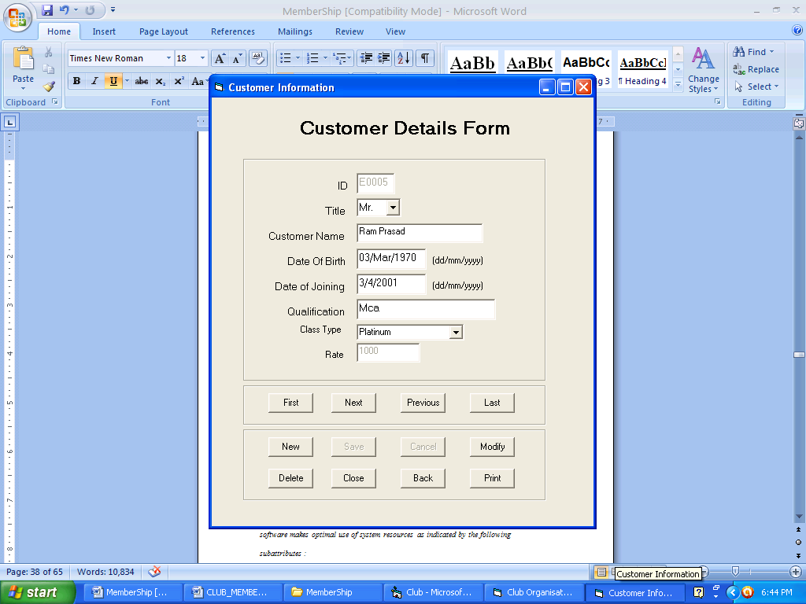

customer bill

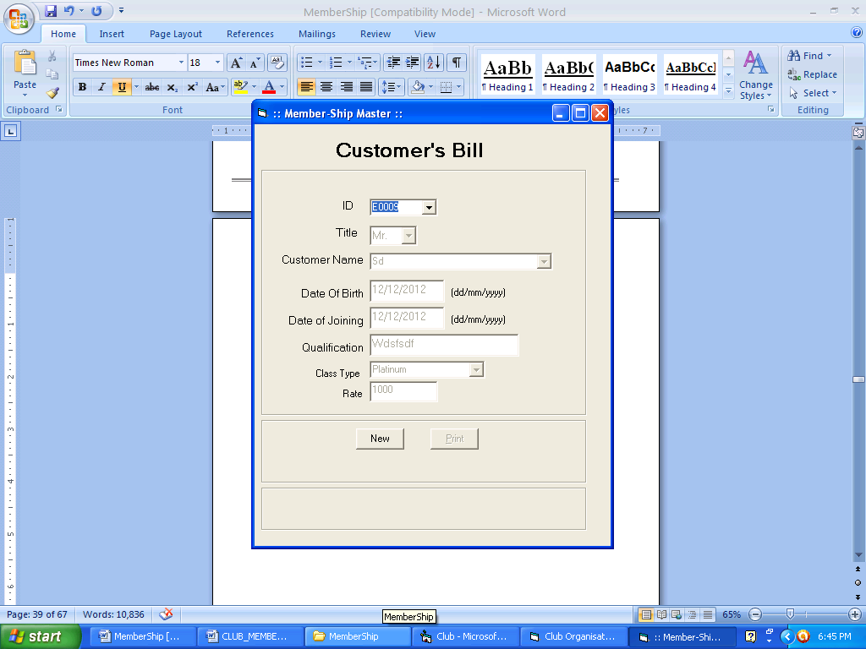

feedback/suggestion

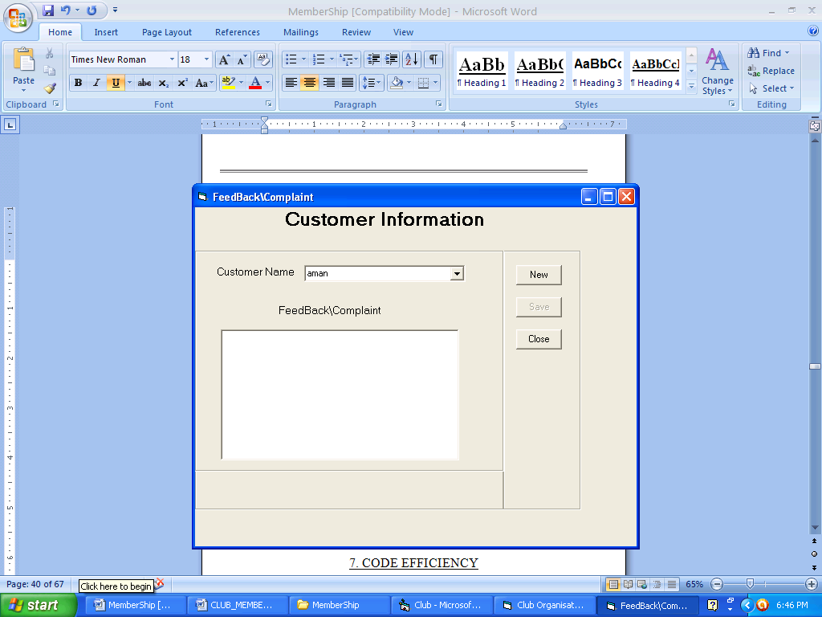

7. Code Efficiency

By the efficiency of a program we mean, the amount of computing resources and code

required by a program to perform its function. Efficiency is the degree to which the

software makes optimal use of system resources as indicated by the following

subattributes :

- time behaviour and
- resource behaviour.

The code of our project is efficient in the sense that it requires minimal number of

computing resources which are easily available and affordable to perform its functions.

Also the code requried by each independent function is also minimal.

8. OPTIMIZATION OF CODE

By optimization of code we mean that how efficiently we have used the different

structures of the coding. To achieve code optimization in our project we have declared

all the variables used in the project on a module. We have declared all the variables as

public so that they can be used as and when required without redeclaring them. Also

several subroutines has been declared public on the module so that they can be used

anywhere in the project when required, thus making optimal use of the code.

9. VALIDATION CHECKS

There are various forms in this project that are being used to submit data to the

database. In order to reduce errors, we have applied a lot of validation checks on various

text boxes such as amount boxes, date boxes etc. so that only valid data can be entered in

these text boxes. Also we have applied certain constraints on tables in oracle, but if any

of the constraint is violated by the user through oracle we cannot compel the user to

change the typed that error, for this we have placed these validations checks. These

validation checks also helps us to reduce typographical errors. These validations checks

also pressurize the user to fill those fields that can’t be left blank. These checks also

convert the alphabets into their suitable case e.g. e-mail address fields will accept every

character in lower case, no matter whether it is entered with caps lock on or off.

Some of the validation checks used in this project are as follows:

VALIDATION CHECK ON AMOUNT BOXES:

The only valid characters that can be entered in boxes accepting amounts are digits from

0 to 9 and decimal(.). Backspace key is also allowed for editing purposes. Furthermore if

an amount box has a maximum length of 12 characters and a user wants to enter only

integer number in this box then this box will accept only a ten digit integer number from

the user and the number will be converted into the format 9999999999.99 . It will help us

in reducing the errors when the data is submitted to the database. In the absence of this

check, we could encounter errors like the entered value is too large for the column.

VALIDATION CHECK ON NAME BOXES:

The only valid characters that can be entered in the text boxes accepting the name of the

customers such as first name , middle name and last name are alphabets from a to z or in

upper case letters from A to Z. Backspace key is also allowed for editing purposes. No

matter whether the character are entered in lower case or in upper case they will be

converted automatically to upper case letters for consistency purposes.

VALIDATION CHECK ON COMBO BOXES:

We have also used some combo boxes, such as for city, state and profession on some

forms. We have applied a validation check on these boxes so that a user is allowed to

only select a value from these boxes. The user can’t enter any value other than that

available in the combo box. This helps us in restricting customers from entering invalid

values.

VALIDATION CHECK ON DATE BOXES:

There are several text boxes accepting dates from users on various forms in our project.

Dates play a very important role in our project because the only basis to determine

whether a customer who was minor at the time of opening the account, has become

mature or not, are the dates. Furthermore transaction dates are also very important for

daily backups. Each user has its own format of writing dates e.g. a user may enter date in

the following formats: 15-09-2002, 15-09-02, 15/09/2002, 15/09/02 or sep 15, 2002 and many more. This may cause a problem. So we have restricted the date format to

dd/mm/yyyy. If the user doesn’t enter the date in the specified format, a message will be

displayed to the user that the format for the date is dd/mm/yyyy. Also the / will appear

automatically after every two characters i.e. a slash / will appear automatically after the

user has entered a valid value for the day and next slash will appear automatically after

the valid value of month. We have also applied a check so that the user can’t enter an

invlid value for the day, month and year. For example if a user enters 32 or more for the

value of day, a message will be displayed showing that the value for day can’t be greater

than 31. Similarly if a user enters a value 13 or more for the month, an appropriate

message will be displayed. Also if the value of the day is 29 or more than 29 and the

value for the month is 02, an appropriate messate will be displayed and the text box will

be made blank. The only valid values for the year are 1901 and more. The system will not

accept dates having year less than or equal to 1900. The date will also be checked for the

validity of leap year. In the case of a leap year a date such as 29/02/2000 is valid

because in a leap year, February is of 29 days. In this way we have reduced the burden

of managing different date formats.

10. TESTING

During system testing, the system is used experimentally to ensure that the software does

not fail. Specific test data are input for processing, and the results examined. It is

desirable to discover any surprises before the organization implements the system and

depends on it.

10.1 TESTING OBJECTIVES :

- Testing is a process of executing a program with the intent of finding an error
.
- A good test case is one that has a high probability of finding an as yet undiscovered error.

- A successful test is one that uncovers an as yet undiscovered error.

10.2 TESTING PRINCIPLES :

- All tests should be traceable to the customer’s requirements.

- Tests should be planned long before the testing begins.

- Testing should begin “in the small” and progress towards “in the large”.

- Exhaustive testing is not possible.

- To be most effective, testing should be conducted by an independent third party.

TESTING

In software development project, errors can be injected at any stage during

development. Because code is the only product that can be executed frequently

and whose actual behavior can be observed, testing is the phase where the

remaining errors from all the previous phases must be detected. Testing performs

a critical role for quality assurance and for ensuring the reliability of software.

During testing, the program to be tested is executed with a set of test cases, and

the output of the program for the test cases is evaluated to determine if the

program is performing as expected. Due to this approach, dynamic testing can

only ascertain the presence of errors in the program; the exact nature of errors is

not usually decided by testing.

Testing a large system is a complex activity, so for a project, incremental testing

is generally performed, in which components and subsystems of the system are

tested separately before integrating them to form the system for system testing.

This form of testing introduces new issues of how to select components and how to

combine them to form systems and subsystems.

10.3 TESTING FUNDAMENTALS

ERROR

It refers to the discrepancy between a computed, observed, or measured value and

true, specified or theoretically correct value i.e. it refers to the difference between

the actual output of the software and the correct value.

FAULT

It is a condition that causes a system to fail in performing its required function. A

fault is the basic reason for software malfunction and is synonymous with the

commonly used term bug.

FAILURE

It is the inability of a system or component to perform a required function

according to its specification. A Software Failure occurs if the behavior of the

software is different from the specified behavior. Faults have the potential to

cause failures and their presence is a necessary but not sufficient condition for

failure to occur.

10.4 TEST CASES AND TEST CRITERIA

Ideally, we would like to determine a set of test cases such that successful

execution of all of them implies that there are no errors in the program. This ideal

goal can’t usually be achieved due to practical and theoretical constraints. Each

test case costs money, as effort is needed to generate the test case, machine time

is needed to execute the program for that test case, and more effort is needed to

evaluate the results.

An ideal test case set is one that succeeds only if there are no errors in the

program. One possible ideal set of test cases is one that includes all the possible

inputs to the program. This is often called exhaustive testing, however it is

impractical and infeasible.

For a given program P and its specification S, a test selection criterion specifies

the conditions that must be satisfied by a set of test cases T. for example, if the

criterion is that all statements in the program be executed at least once during

testing, then a set of test cases T satisfies this criterion for a program P is the

execution of P with T ensures that each statement in P is executed at least once.

There are two fundamental properties for a testing criterion: reliability and

validity. A criterion is reliable if all the sets of test cases that satisfy the criterion

detect the same errors. A criterion is valid if for any error in the program there is

some set satisfying the criterion that will reveal the error.

Testing can be mainly of two types :

10.5 BLACK BOX TESTING :

When we know the specified function that a product has been designed to perform, tests

can be conducted that demonstrate each function is fully operational while at the same

time searching for errors in each function. A black box test examines some fundamental

aspect of a system with little regard for the internal logical structure of the software.

Black box testing also called behavioral testing, focuses on the functional requirements

of the software. Black box testing attempts to find errors in the following categories:

- Incorrect or missing functions.
- Interface errors.
- Errors in data structures or external database access.
- Behaviour or performance errors.
- Initialization and termination errors.

10.6 WHITE BOX TESTING :

When we know the internal workings of a product, tests can be conducted to ensure that

internal operations are performed according to specifications and all internal

components have been adequately exercised. This testing is sometimes called as glass

box testing. Using white box testing methods, the software engineer can derive test cases

that

- guarantee that all independent paths within a module have been exercised at least once
- exercise all logical decisions on their true and false sides
- execute all loops at their boundaries and within their operational bounds
- exercise internal data structures to ensure their validity

In this project our main emphasis is on white box testing .

In order to test loops, we used the loop testing technique which is a white box testing

technique. Most of the loops used in this project belong to the category of simple loops.

We applied the following set of tests to test loops, where n is the maximum number of

allowable passes through the loop.

- Skipped the loop entirely.

- Allowed only one pass through the loop.

- Allowed two passed through the loop.

- Allowed m passed through the loop where m < n.

- Allowed n-1, n, n+1 passes through the loop.

In order to test the control flow structures such as if conditions etc. we used the

condition testing technique. The condition testing method focuses on testing each

condition in the program. Condition testing strategies have two advantages. First,

measurement of test coverage of a condition is simple. Second, the test coverage of

conditions in a program provides guidance for the generation of additional tests for the

system. Branch testing is the simplest condition testing strategy. For a compound

condition C which is composed of two or more simple conditions, boolean operators and

parenthesis, the true and false branches of C and every simple condition in C need to be

executed at least once.

10.7 BOUNDARY VALUE ANALYSIS :

For reasons that are not completely clear, a greater number of errors tend to occur at the

boundaries of the input domain rather than in the ‘center’. It is for this reason

that boundary value analysis has been developed as a testing technique.

Boundary value analysis leads to a selection of test cases that exercise bounding

Values. We used this approach to test several control statements in our project.

Guidelines for boundary value analysis are as follows:

- If an input condition specifies a range bounded by values a and b, test cases should be designed with values a and b and just above and just below a and b.

- If an input condition specifies a number of values, test cases should be developed that exercise the minimum and maximum numbers. Values just above and below minimum and maximum are also tested.

- Apply the same guidelines to output conditions.

- If internal program data structures have prescribed boundaries, be certain to design a test case to exercise the data structure at its boundary.

10.8 FUNCTIONAL TESTING :

In functional testing, the structure of the program is not considered. Test cases

are decided solely on the basis of the requirements or specifications of the

program or module, and the internals of the module or the program are not

considered for selection of test cases. Due to its nature, functional testing is often

called, “black box testing”.

10.9 STRUCTURAL TESTING :

In the structural approach, test cases are generated based on the actual code of

the program or module to be tested. This structural approach is sometimes called

“glass box testing”.

10.10 LEVELS OF TESTING :

The basic levels are unit testing, integration unit testing, and system and acceptance testing.

10.10.1 UNIT TESTING :

In this different modules are tested against the specifications produced during

design for the modules. Unit testing is essentially for the verification of the code

produced during the coding phase and its goal is to test the internal logic of the

modules. It is typically done by the programmer of the module. Structural testing

is best suited for this level.

In our project each form works like a unit. Some forms are used to display the

data stored in the database and some forms are user to submit data to the

database. Before submitting the data to the database, it is tested individually

using front end capabilities. The tests that occurred as part of the unit tests are as follows:

- The module interface was tested to ensure that information properly flows into and out of the program unit under test.

- The local data structures were examined to ensure that data stored temporarily maintains its integrity during all steps in an algorithm’s execution.

- Boundary conditions were tested to ensure that the module operates properly at boundaries established to limit or restrict processing.

- All independent paths through the control structure were exercised to ensure that all statements in a module have been executed at least once.

- Finally, all error handling paths were tested.

10.10.2 INTEGRATION TESTING :

Integration testing is a systematic technique for constructing the program

structure while at the same time conducting tests to uncover errors associated

with interfacing. The objective is to take unit tested components and build a

program structure that has been dictated by design.

Integration can be either top down or bottom down.

Top down integration testing is an incremental approach to construction of

program structure. Modules are integrated by moving downward through the

control hierarchy, beginning with the main control module. Modules subordinate

to the main control module are incorporated into the structure in either a depth

first or breadth first manner.

Bottom up integration testing begins construction and testing with atomic

modules (i.e. components at the lowest levels in the program structure). Because

components are integrated from the bottom up, processing required for

components subordinate to a given level is always available and the need for

stubs is eliminated.

In our project, we have used the bottom up approach. When all the forms were

tested independently, they were integrated to form a module.

10.10.3 REGRESSION TESTING :

Each time a new module is added as part of integration testing, the software

changes. New data flow paths are established, new I/O may occur, and new

control logic is invoked. These changes cause problems with functions that

previously worked flawlessly. In the context of an integration test strategy,

regression testing is the re-execution of some subset of tests that have already

been conducted to ensure that changes have not propagated unintended side

effects. Regression testing was used frequently in our project.

10.10.4 VALIDATION TESTING :

At the culmination of integration testing, software is completely assembled as a

package, interfacing errors have been uncovered and corrected, and a final series

of software tests– validation testing– may begin. Validation can be defined in

many ways, but a simple definition is that validation succeeds when software

functions in a manner that can be reasonably expected by the customer.

10.10.5 SYSTEM AND ACCEPTANCE TESTING :

System testing is actually a series of different tests, whose primary purpose is to

fully exercise the computer based systems. Although each test has a different

purpose, all work to verify that system elements have been properly integrated

and performed allocated functions. The following types of system tests are

worthwhile for software based systems : recovery testing, security testing, stress

testing, performance testing. At this level of testing, the entire software system is

tested. The reference document for this process is the requirement document. Its

goal is to verify if the software meets its requirements. It is essentially a

validation exercise, and in many situations it is the only validation activity.

Acceptance testing is sometimes performed with realistic data of the client to

demonstrate the software is working satisfactorily. Testing, here focuses on the

external behavior of the system, the internal logic of the program are not

emphasized. Consequently, mostly functional testing is performed at these levels.

After self testing, it is tested by the different persons present in the lab and staff

members along with students and accepted by them.

Client Needs
Requirements
Design
Code
Acceptance Testing
System Testing
Integration Testing
Unit Testing

In general, testing commences with a test plan and terminates with acceptance

testing. A test plan is a general document for the entire project that defines the

scope, approaches to be taken, and the schedule of testing as well as identifies the

test items for the entire testing process and the personnel responsible for different

activities of testing.

The inputs for forming the test plan are: -
- Project plan
- Requirement Document
- System Design Document

The project plan is needed to make sure that the test plan is consistent with the

overall plan for the project and the testing schedules matches that of the project

plan.

The requirement document and the design document are the basic documents

used for selecting the test units and deciding the approaches to be used for

testing.

A test plan should contain the following testing: -

- Test unit specification

- Features to be tested

- Approaches for testing

- Test deliverables

- Schedule

- Personnel allocation

TEST UNIT :

A test unit is a set of one or more modules together with associated data, that are

form a single computer program and that are the objects of testing

FEATURES TO BE TESTED :

It includes all software features and combination of features that should be tested.

A S/W feature is a software characteristic specified or implied by the

requirements or design documents. These may include functionality, performance,

design constraints, and attributes.

APPROACH FOR TESTING :

It specifies the overall approach to be followed in the current project. The

techniques that will be used to judge the testing effort should also be specified.

TESTING DELIVERABLES :

Testing Deliverables should be specified in the test plan before the actual testing

begins. Deliverables could be a list of test cases that were used, detailed results of

testing, test summary report, test log and data about coverage.

SCHEDULE :

A schedule specifies the amount of time and effort to be spent on different

activities of testing, and testing of different units that have been identified.

PERSONNEL ALLOCATION :

It identifies the persons responsible for performing the different activities.

11. IMPLEMENTATION

A crucial phase in the system life cycle is the successful implementation of the new system

design. Implementation includes all those activities that take place to convert from the

old system to the new one. The new system may be completely new, replacing an existing

manual or automated system or it may be major modification to an existing system. In

either case , proper implementation becomes necessary so that a reliable system based on

the requirements of the organization can be provided. Successful implementation may not

guarantee improvement in the organization using the new system, but improper

installation will prevent it. It has been observed that even the best system can’t show

good result if the analysts managing the implementation do not attend to every important

details. This is an area where the systems analysts need to work with utmost care.

This system will be implemented using VB 6.0 as front end and Oracle 8 as back end and

Windows 98 as the platform.

For the successful implementation of a system, the training of the users of the system

plays an important role. Because even well designed system can succeed or fail because

of the way the are operated and used. Therefore, the quality of the training received by

the personnel involved with the system in various capacities helps or hinders and may

even prevent the successful implementation of management information system. Those

who are directly or indirectly related with the system development work must know in

detail what their roles will be, how they can make efficient use of the system and what the

system will or will not do for them. Therefore both system operators and users need

training.

SYSTEMS OPERATORS TRAINING :

Running of the system successfully depend on the personnel working in the computer

center. They are responsible for providing the necessary support. Their training must

ensure that they are able to handle all possible operations, both routine and extra-

ordinary in nature. Operators training should include such fundamentals as how to turn

the equipment on and use it, how to power off and a knowledge of what constitutes

normal operation. The operators should also be trained on different type of

malfunctioning, how to recognize them and what steps should be taken whenever they

arise. As part of their training, operators should be given both a troubleshooting list that

identifies possible problems and remedies for them, as well as the names and telephone

numbers of individuals to contact when unexpected or unusual problem arise. Training

also involves familiarization with run procedures, which involves working through the

sequence of activities needed to use a new system on an ongoing basis.

USER TRAINING :

User may be trained on use of equipment, particularly in the case where, for example, a

micro-computer is in use and the individual involved is both operator and user. In such

cases , users must be given training on how to operate the system also. Questions that

may be trivial to the analyst, such as how to turn on a terminal, how to insert a diskette

into a micro-computer, or when it is safe to turn off the equipment without danger of data

loss, are significant problems to new users who are not familiar with computers.

This is also the case with our system. In most of the cases, user training deals with the

operation of the system itself, with proper attention given to data handling techniques. It

is imperative that users be properly trained in methods of entering transactions, editing

data, formulating inquiries, deleting and inserting of records. No training is complete

without familiarizing users with simple systems maintenance activities. Weakness in any

aspect of training may lead to awkward situations that cause user frustration and errors.

In our project also it is necessary to train users on how to commit the transactions.

Training of operators and users can be organized in several different ways. Most

important ways to train users are

- Vendor and in-service training

- In-house training

Often the best source of training on equipment is the vendor who supplies the equipment.

Most vendors offer extensive educational programs as part of their services. In the case

of our project too, we’ll provide training to the users of our project.

Conversion is also important in the implementation phase. Conversion is the process of

changing from the old system to the new one. It must be properly planned and executed.

Four methods of conversion are common in use. They are :

- Parallel systems

- Direct conversion

- Pilot systems

- Systems phase-in

Each method should be considered in the light of the opportunities that it offers and

problems that it may create. However, it may be possible that sometimes, we may be

forced to apply one method over others, even though other methods may be more

beneficial. In general, systems conversion should be accomplished in shortest possible

time. Long conversion periods create problems for all persons involved including both

analysts and users.

PARALLEL SYSTEMS :

The most secure method of converting from an old to new system is to run both systems in

parallel. Under this approach, users continue to operate the old system in the usual

manner but they also start using the new system. This method is the safest one.

DIRECT CONVERSION :

This method converts from the old system to the new system abruptly, sometimes over a

weekend or even midnight. The old system is used until a planned conversion day, when it

is replaced by the new system. There are not parallel activities.

PILOT SYSTEM :

Pilot approach is often preferred in the case of the new system which involves new

techniques or some drastic changes in organization performance. In this method, a

working version of the system is implemented in one part of the organization, such as a

single work area or department.

PHASE-IN METHOD :

This method is used when it is not possible to install a new system throughout an

organization all at once. it allows some users to take advantage of the new system early.

Also it allows training and installation without unnecessary use of resources.

The project developed by us should be implemented using the parallel systems conversion

method.

12. MAINTENANCE

Maintenance is the enigma of system development. It holds the software industry captive, tying up programming resources. Analyst and programmers spend more time maintaining programs than they do writing them.
The software will definitely undergo change once it is delivered to the customer. There can be many reasons for this change to occur. Change could happen because of some unexpected input values into the system. In addition, the changes in the system could directly affect the software operations. The software should be developed to accommodate changes that could happen during the post implementation period.
After the installation phase is completed and the user staff is adjusted to the changes created by the system evaluation and maintenance begins.

Evaluation
System is evaluated to the great extent and the user requirements are met. What we specified in the performance criteria has been achieved. We also take feedback from the user about the software and are they fully satisfied. The criticism from the users, and suggestions for improvement are also invited to make our software more reliable.

Maintenance
Should System be modified?
This question arises when the system is need to be modified according to the user if he wants to make changes because of previously uncorrected errors. We have four types of maintenance according to which users make changes in the software-
Adaptive maintenance
Perfective maintenance
Corrective maintenance
Preventive maintenance

Adaptive maintenance
Adaptive maintenance means changing the program function.
Over time, the original environment (e.g., CPU, Operating system, business rules, external product characteristics) for which the software was developed is likely to change. Adaptive maintenance results in modification to the software to accommodate changes to its external environment.

Perfective Maintenance
It means enhancing the performance or modifying the programs to respond to the user’s additional or changing needs.

Corrective Maintenance
It means repairing, processing or performance failure or making changes because of previously false assumptions.
Even with the best quality assurance activities, it is likely that the user will uncover defects in the software. Corrective maintenance changes the software to correct defects.

Preventive maintenance
Computer software deteriorates due to changes, and because of this preventive maintenance, often called software reengineering, must be conducted to enable the software to serve the needs of its end users. In essence, preventive maintenance makes changes to computer programs so that they can be more easily corrected, adapted, and enhanced.

Enhancement
It means adding, modifying, or redeveloping the code to support changes in the specifications. It is necessary to keep up with changing user needs and the operational environment.
As software is used, the user will recognize additional functions that will provide benefit. Perfective maintenance extends the software beyond its original functional requirements.

13. REPORTS

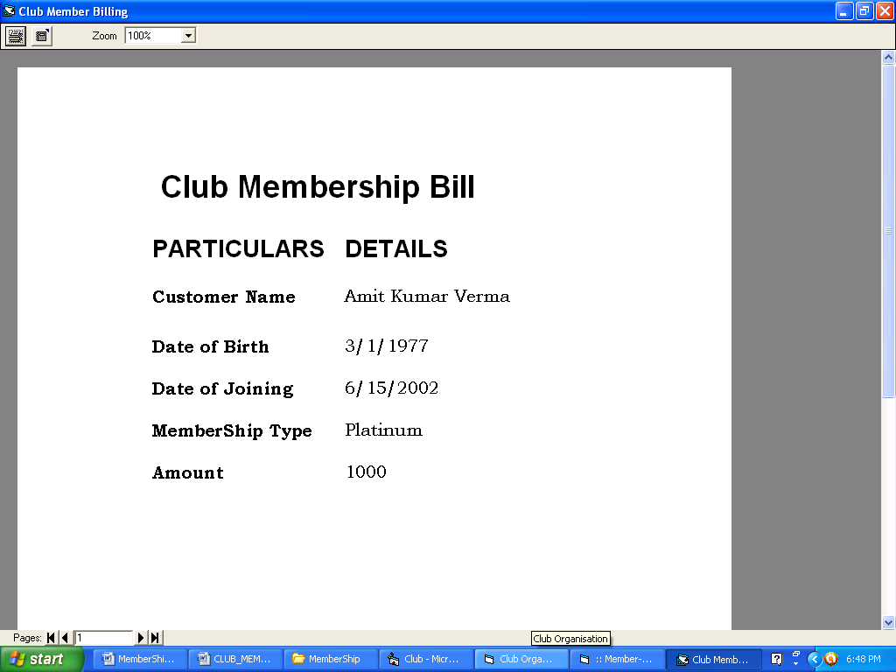

FUTURE APPLICATION OF THE PROJECT

The future of the Project looks more promising.

The main advantage of this project is all about Member ship management system. The extra feature involved in our member ship project is that it is you can easily give the value able feed back and suggestion for of this project.

In future, we can have the SMS facility for the customer and customer search engine that can provide the result on the basis of different criteria to search. We can also have one more module of implementing this project

.

14. BIBLIOGRAPHY

- Mastering Visual Basic 6
Author(s) : Evangelos Petroutsos
Publisher : BPB Publications

- Oracle : The Complete Reference
Author(s) : Robert Koch
Publisher : Tata McGraw-Hill

- SQL, PL/SQL The Programming Language of Oracle
Author(s) : Ivan Bayross
Publisher : BPB Publications

- Software Engineering A Practitioner’s Approach (fifth edition)
Author(s) : Roger S. Pressman
Publisher : Tata McGraw-Hill

- Fundamentals Of Software Engineering
Author(s) : Carlo Ghezzi, Mehdi Jazayeri, Dino Mandrioli
Publisher : Prentice Hall of India

